**XML to JSON using XSLT Mediator**

1. Click on file select integration project.

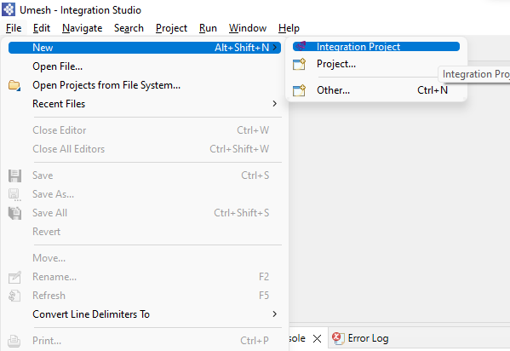

1. Select ESB config and Composite Exporter and enter name of project and click on finish.

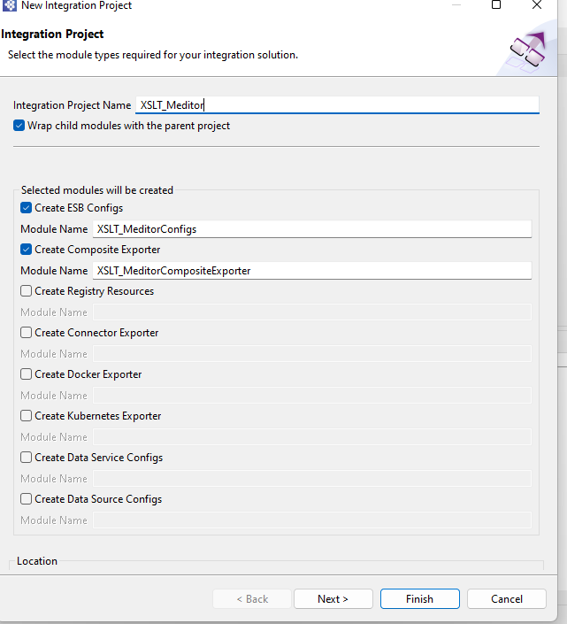

1. Right Click on API artifact in ESB Config and click new, select REST API

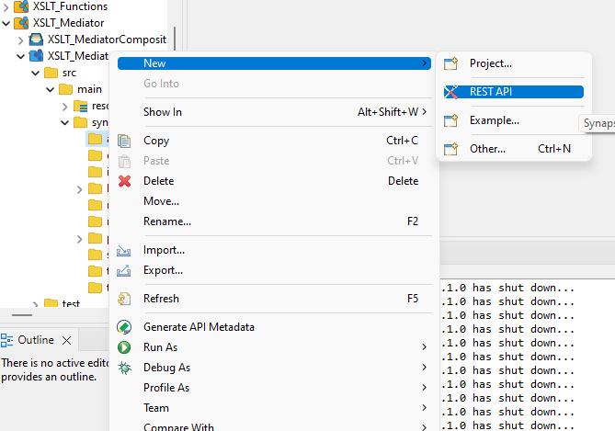

1. Select Create new API artifact and click on next.

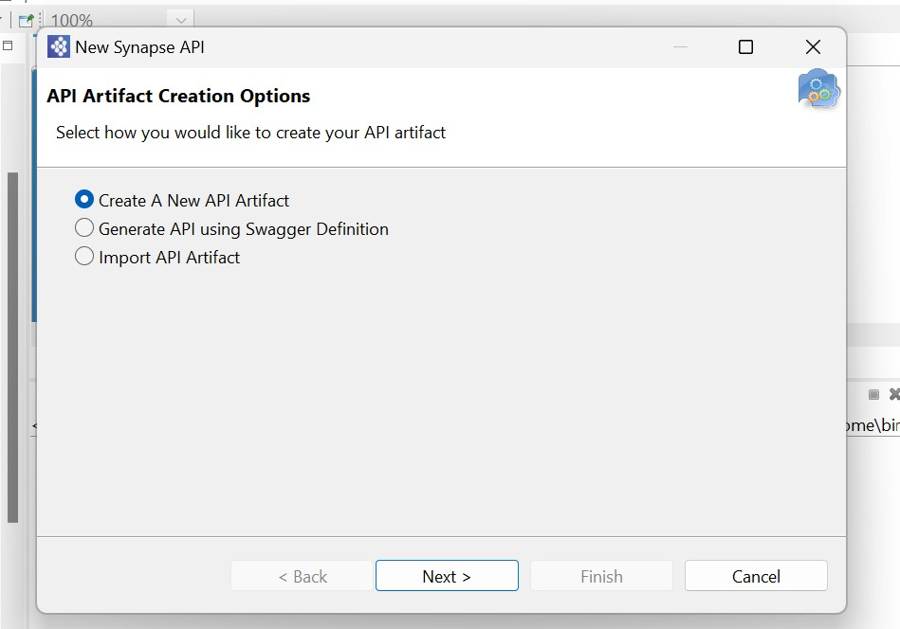

1. Enter Name and context of API and click on next.

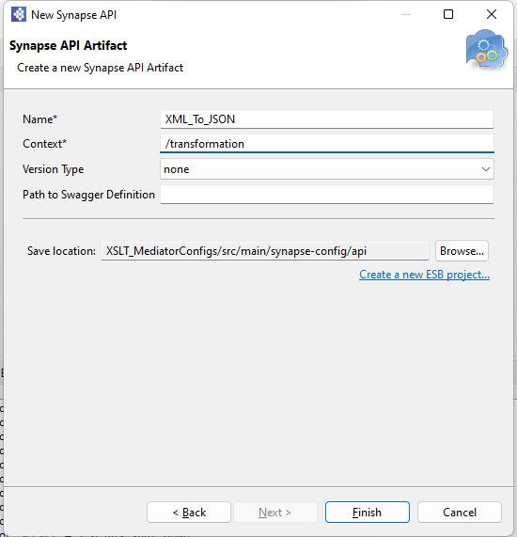

1. Double-click the Resource icon on the left side of the canvas.
2. On the Properties tab, provide the following as Basic properties:

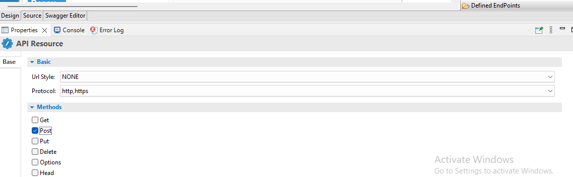

1. Right Click on local-entries artifact in ESB Config and click new and select create new local entry

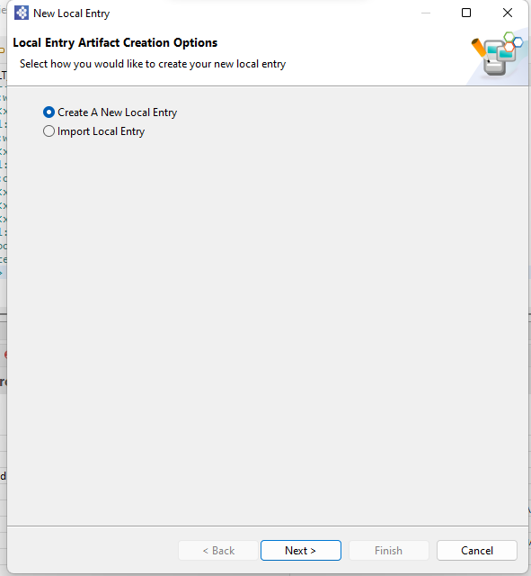

1. Enter name of local entry, code in value tab, select In Line XML Entry and click on finish

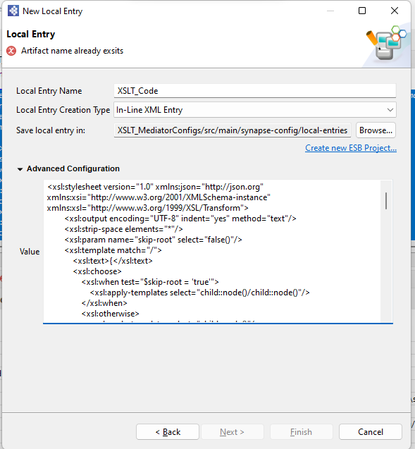

1. From the **Mediator** palette, click and drag a **XSLT** Mediator to the In sequence

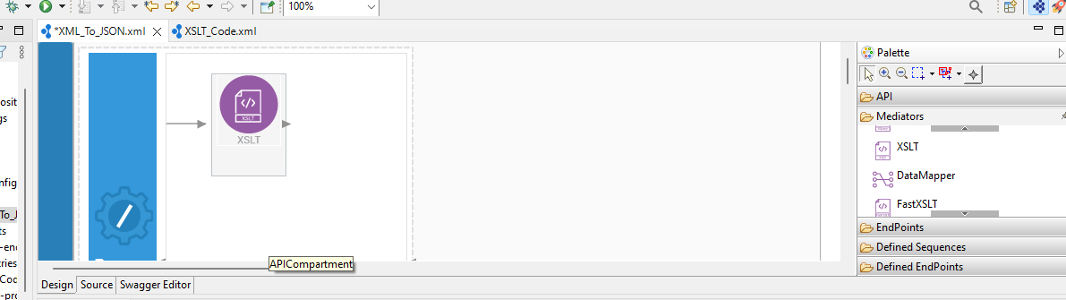

1. In XSLT mediator property tab click Xslt static schema key

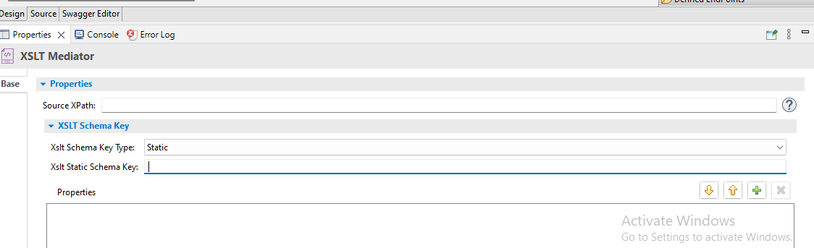

1. Select workspace

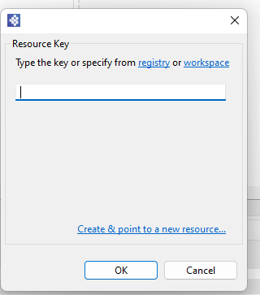

1. Select local entry and click on OK

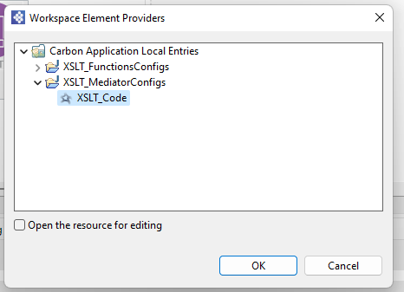

1. From the **Mediator** **palette**, click and drag a respond **Payload Factory** to the In sequence

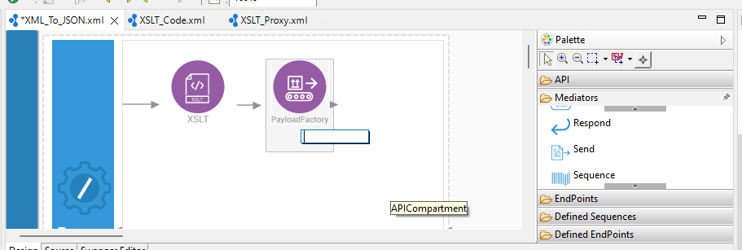

1. Select media type json and enter argument value in property tab of Payload Factory

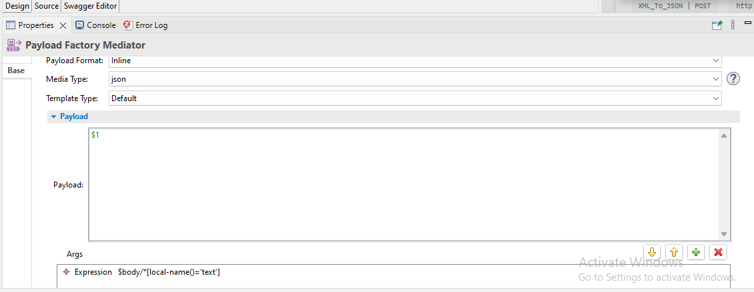

1. From the **Mediator** **palette**, click and drag a respond **Mediator** to the In sequence

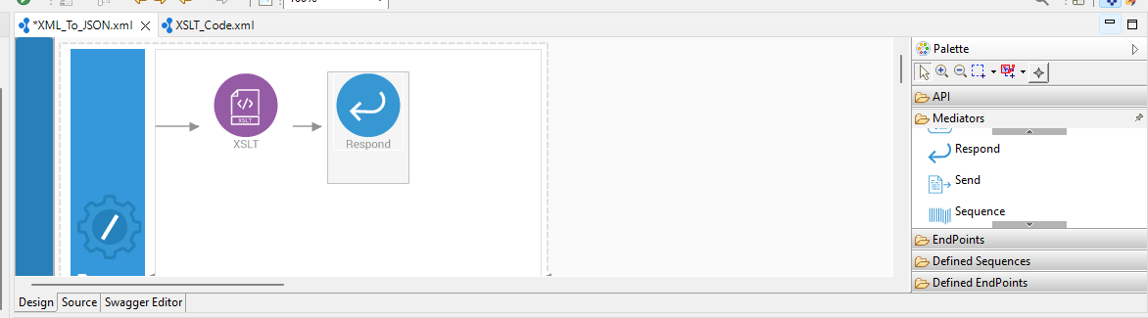

1. Right Click on the Composite Exporter and select Export project artifact and Run

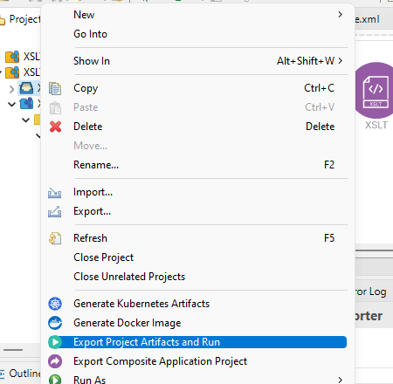

1. In post enter URL, select POST method, enter input payload and Click on Send Button get response.

